SMART AI BASED DEGRADATION CONVERTER CONTROL FOR EV CHARGING BATTERY

Dr.M.P.MOHANDASS,
Department of Electrical and Electronics Engineering,
KIT-KalaignarKarunanidhi
Institute of Technology, Coimbatore, India.
mohandassmp@gmail.com

S. JOYAL GOODWIN,
Electrical and Electronics Engineering,
KIT-KalaignarKarunanidhi Institute of Technology,
Coimbatore,India. kit27.eee024@gmail.com
R. KANISH,
Electrical and Electronics Engineering,
KIT-KalaignarKarunanidhi
Institute of Technology,
Coimbatore, India.
kit27.eee026@gmail.com
A.DINESH,
Electrical and Electronics Engineering,
KIT-KalaignarKarunanidhi
Institute of Technology,
Coimbatore, India. kit27.eee013@gmail.com

ABSTRACT

The degradation of EV batteries is usually higher when fast-charging methods are used consistently over time. Most charging systems overlook the battery's aging, which leads to thermal stress, rising temperatures, and a shorter expected lifespan. This paper introduces a smart AI-assisted charging system that adjusts the charging method based on the battery's health in real-time. The system tracks important battery parameters like voltage, current in the charging circuit, and temperature using built-in sensors. A microcontroller analyzes this data to evaluate battery degradation using AI models. It then changes the charging profile by controlling its DC-DC converter. Aging batteries switch to a slower and safer charging mode, which lessens stress and thermal effects. A simple LED indication system makes this setup easy to use. A green LED lights up when the battery is in good condition, while a red LED shows that the battery is old or degraded and needs slow charging to extend its life and ensure safety. Finally, to test how practical the system is, a real-time prototype was developed using battery sensors, a microcontroller platform, and an AI module. This prototype demonstrated an increase in battery life compared to traditional charging methods due to reduced heating and stress on the battery.

(KEYWORDS : Electric Vehicle , Battery Degradation, State of Health (SoH), Battery Management System (BMS),AI Module )

I . INTRODUCTION

The Increase in development of electric vehicles has created a requirement for efficient, dependable with smart battery charging systems. Battery degradation is still a big problem were this paper focuses on common types of technology needed and their impacts on the performance, safety and lifespan

of the vehicles, particularly on the battery degradation. Battery degradation occurs due to several factors such as low level of capacity and degradation in efficiency. The low capacity and degradation in efficiency occur faster with increase in number of charge and discharge cycles, high charging rate and thermal effects [1], [4].

Current methods for charging electric vehicles typically employ static charging methodologies such as Stable current or Stable voltage without any reference to the battery’s real-time health status. Excessive temperature, increased internal resistance and decreased battery lifetime can be observed during fast charging scenarios without the implementation of dynamic charge rate management. Studies have recently concluded that the strategy of charging can be adjusted to cater to a battery’s health in order to prevent degradation and enhance long-term system performance[1],[5].For the aforementioned tasks, various machine learning techniques such as deep learning networks, transformers, and mixed approaches have been exploited in literature for health degradation prediction, anomaly detection, and estimation of the battery remaining useful life (RUL)[9],[10]. For accurate battery health estimation of batteries also AI-based models handle large amount of real-time monitored voltage level, current level, and temperature data to accurately estimate battery health under diverse operating conditions and multiple loading levels[6],[7]. Intelligent charging control techniques have also been investigated in the literature to improve battery performance[18]. For optimal charging efficiency and dynamically suitable charging current profiles, recent approaches apply AI techniques to optimize power electronic interfaces, such as DC–DC converters, and reconfigurable charging units [3],[17]. Some systems support mode transition from fast to slow charge in accordance with state of battery, thereby preventing excessive stress and improving safety.

II . EXISTING METHODOLOGY

Nearly all previously designed EV charging systems have an old-style charging methodology that utilizes a Stable current-Stable voltage profile & remains constant during the entire charging duration. Although many of these systems are often implemented because of their ease of implementation, they have not accounted for the present state-of-health (SoH) & also the current degradation level of the lithium-ion batteries being charged. Therefore, all batteries have been subjected to the same conditions of fast-charging or high-current charging rates of all batteries, resulting in excessive heat generation, increased internal resistance & prematurely aging batteries [2], [15].Some improvements have been made in recent times with the integration of advanced power-electronic converters with programmable controls (I.e. programmable charging circuitry). The use of DC-DC converters in a charging system allows for better control over both the voltage and current, thereby improving the efficiency of the charging process [3], [17]. Some of the methods discussed go further to incorporate machine learning or artificial intelligence to predict battery degradation and determine the optimal charging characteristics for that battery at the time of charging. Additionally, these systems will collect & evaluate different parameters (e.g. voltage, current & temp) to determine their health & performance based on how they will operate under various different conditions.Parameters like voltage and current as well as temperature can be measured with these types of systems and can then be used to help assess a battery's state of health and battery performance based on how it performs under different operating conditions. However, while progress has been made in terms of providing these types of services, there has yet to be any provision for intuitive method of indicating the present health of a battery during charging via real-time feedback to the user.

III . LITERATURE SURVEY

The Increased Development of electric vehicles charging patterns has become the focus of researchers who wish to study how varying electric vehicle charging techniques affect the physical properties of battery systems. The combination of temperature effects, chemical phenomena, and usage patterns creates unpredictable battery degradation patterns. Current empirical models fail to cope because of the complex scenario situation that arises. The researchers look at scenarios that unpredictably happen because each cycling effect produces random effects they have to study. New literature on lithium-ion batteries for electric vehicles is increasingly focused on the knowledge of degradation behaviour which helps in the accuracy of prediction while enhancing charging strategies using state-of-the-art data-driven methodologies.The high-level demerits of traditional empirical electrochemical models necessitating an introduction to machine learning and deep learning methods which can deal adequately with the complex non-linear charge carrier behaviour of batteries [8], [13]. Text transformers and generative models can predict early degradation, as they can learn from long-term usage patterns of batteries [1]; studies of degradation path prediction show that aging behavior is mostly determined by actual operating sequences rather than standardized laboratory test conditions [4], [7]. The development of machine learning tools for real-life automotive environments shows how important the influence of environmental factors and operational equipment differences are for reliable assessments of degradation [6]. The research studies a hybrid models of machine learning and an anomaly detection framework for predictive maintenance but the models fail because of poor quality data and issue of suitable feature selection [5]. The use of models with hybrid deep learning architectures has shown better performance for early degradation forecasting and improved accuracy for aging estimation [10] [11]. The first solution for data shortage problems is using quantum neural networks together with data that is created from generative AI, but still has a limited practical application. According to [9], although deep learning approaches outperform existing techniques in RUL estimation research, maintaining their advantages while controlling the performance overfitting issue is an issue that requires further attention. Scientists have spent so much time studying how batteries are charged that they tend to predict technique in the most attention. This is because fast charging methods do reduce charging times but they do cause thermal stress. This thermal stress causes the battery to degrade faster [2] [18]. According to the research, intelligent charging systems utilize internal battery state information for controlling their operations to enhance battery life and operational performance [16]. The relationship of charging systems at both levels with the operation of converters and battery system performance impact [15]. The system integration development contains two elements such as reconfigurable converter-based charging systems and model predictive control systems which improve the efficiency and flexibility of connectivity of the renewable energy systems to the power system [3][17]. The thermal regulation of batteries is necessary for improving the efficiency and lifespan of lithium-ion batteries. An innovative thermal management system for batteries using LABVIEW has been developed to constantly monitor and maintain the temperature of batteries to avoid overheating [21].Future research should develop lightweight solutions which enable real-time deployment through the integration of an accurate prediction model which will helps in betterment in the lifespan of the batteries.

IV. PROPOSED METHODOLOGY
Paper, we present an intelligent electric vehicle charging system that incorporates degradation aware technology for optimising charging operation by immediately determining battery health. The system consists of three key elements. These elements include sensor based monitoring, AI based decision making and adaptive charging and control with user interaction by simple to the eye LED indicators. In the system, special sensors are used to monitor the battery parameters such as voltage data, current and temperature data during testing. A microcontroller (ESP32) processes the acquired data, and an AI based model is used to predict the battery health of the battery and detail its operational status between healthy and aged. A DC-DC buck converter is utilised to switch to alternative charging strategies based on analysis results. Therefore, the system automatically switches to slow charging in order to prevent damage to battery and other components should the battery has aged or degraded. The system has an adaptive approach to charging, thus the system can operate at its full charging capability while also increasing the lifespan and reserve capacity of battery. Finally, the system incorporates a simple to the eye LED indicator system to satisfy user's requirements. A green LED is used to indicate that battery health allows for fast charging, whereas a red LED is used to indicate that slower and safer charging is required.
ADVANTAGES OF THE PROPOSED SYSTEM
The system delivers the first major feature of long life battery support by enabling the system to adjust the charging speed as the battery is filled. The system does not utilize fixed charging profiles and instead chose a flexible set of profiles that reduce stress on the battery and increase performance. The second major feature is how the system decreases and prevents damage to the batteries. The system actively uses slow charging to protect old batteries and increases the longevity of the batteries by keeping heat and internal resistance down and also reducing any kind of electrochemical damage. This process supports the extended life of the battery while also keeping performance at optimum levels.
ROLE OF AI IN PROPOSED SYSTEM
This EV charging system utilises artificial intelligence (AI) to provide intelligent charging, which is continually adapting based on real-time measurements of battery voltage & current, temperature and state of charge . These measurements are continually processed by the ESP32 to be fed into an AI model, enabling the system to estimate the batteries health level - healthy or aged. The charging speed is determined by the charging system based on whether the battery is healthy or aged, to protect and for maximise life by keeping the stress and aging as low as possible. The system is a fully closed loop, continually monitoring and adjusting the charging parameters as necessary. LED indicators are provided to give a simple to the user an indication of the batteries current status.
AI MODEL ARCHITECTURE:

We are employing a simple Artificial Neural Network (ANN) for the purpose of predicting the battery’s health.

Input Parameters taken by the model:

Three parameters provide input to the ANN:
- Battery Voltage
- Charging Current
- Battery Temperature

Architecture of the ANN model:

- Input Layer: 3 nodes
- Output Layer: 1 node

Output provided by the model:

- For a healthy battery, charging is rapid.
- In case of an aged battery, the charging is comparatively slow.

Training Methodology:

- Collection of charging events with data points for voltage, current, and temperature

- Marking each data point as either healthy or aged
- Training of the model via Python programming and TensorFlow framework
- Deployment of the model to the ESP32 device or control unit

Background on the dataset:

The collected data is obtained through different settings:
- Charging cycles of new batteries
- Charging cycles of old batteries
- Fast charging cycles

V MATHEMATICAL EQUATION
These formulas are used for battery monitoring, AI input parameters, and converter control.

To Find Battery Health :
SOH = (Ccurrent / Crated) × 100 (1)
Where:
Ccurrent = Current capacity of Battery
Crated = Original battery capacity.

To Find Rise Of Battery Temperature:

Q = (I*I)*R*t (2)
Where:
Q = Generated Heat I = Current
R = Internal resistance t = Time

TABLE [1]: QUANTITATIVE VALIDATION AGAINST EXISTING AI-BASED CHARGING SYSTEMS:

CONTENT | EXISTING AI MODULE | PROPOSED AI MODULE
CHARGING SAFETY | PROVIDE GOOD SUPPORT | PROVIDE BETTER WITH MONITORING
BATTERY  HEATING | OCCUR MEDIUM HEATING | PROVIDE LESS HEATING
BATTERY  LIFE | MAXIMUM UPTO 2.5 YRS | MAXIMUM UPTO 3+ YRS
CHARGING EFFICIENCY | UPTO 89 % | UPTO 93%
BATTERY LIFE IMPROVEMENT | WITH UPTO 15% | WITH UPTO 25%

- Battery life increases
- Temperature reduces
- Charging efficiency improved

- In This Table [1] Shows the comparison of the two AI charging modules which is the present one and the upgraded one .
- This shows that there is significant enhancement in the battery’s operation and safety. It must be noted that the existing AI module can give good charging service, but the upgraded module gives an edge over the old one due to its capacity to monitor voltage, current, and temperature in real time.
- The present AI module generates heat to some degree, while the upgraded module considerably reduces the heat due to optimized charging speed.
- This has led to a higher battery life, increasing from 2.5 years to more than 3 years.

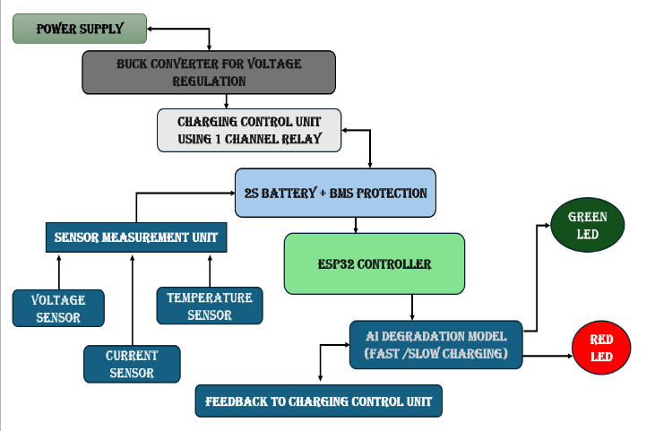
FIGURE [1]: FUNCTIONAL FLOWCHART OF SYSTEM
In this Figure [1] Explains project presents a new AI based architecture for EV charging based on battery health. A small buck converter feeds power from a DC power supply to charge a 2S lithium-ion battery with integrated BMS protection. Charging is controlled by a simple relay-based switching circuit. A small unit of sensors captures battery voltage, charging current and ambient temperature. An ESP32 microcontroller processes the incoming data to determine the health of the battery. The AI-based model uses machine learning algorithms to assess if the battery is healthy or aged due to stress of cyclic charging/discharging. Fast charging is proposed for healthy batteries to extract maximum energy storage capacity. Conversely, slow and safe charging practice is recommended to maintain battery health and life. A simple green or red LED is used to indicate the battery health status. The closed feedback loop of the system also allows dynamic adjustments of the real-time charging process to obtain maximum efficiency, safety and battery life.

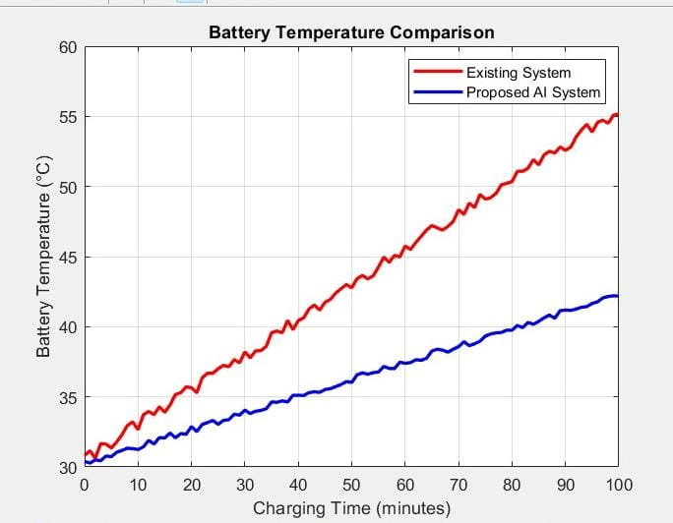

FIGURE [2] : BATTERY TEMPERATURE COMPARISON
In This Figure [2] above plots battery temperature increase as a function of charging time for the current system and the new AI-powered system. The current system shows a sharp temperature increase from 30°C to 55°C over the course of 100 minutes of fast charging. In contrast, the new system shows a slower increase in temperature, peaking at 42°. The system is able to maintain lower temperature increases as it dynamically adjusts charging rate to maintain the health of the battery. This results in improved safety and longer battery life.
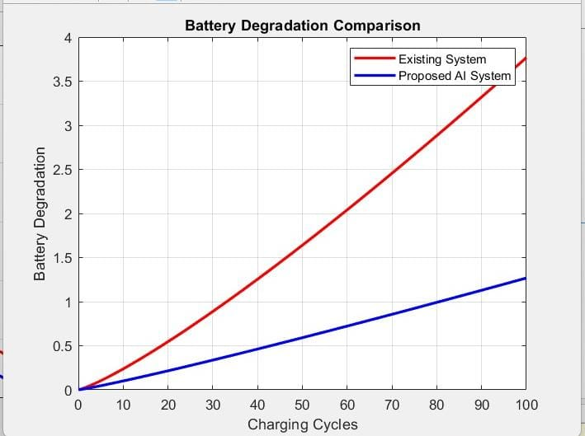
FIGURE [3]: BATTERY DEGRADATION COMPARISON

In This Figure [3] explains the degradation of battery life over multiple charging cycles. Although the system still exhibits rapid degradation, it reaches only approximately 3.8 units after 100 charging cycles. As discussed earlier, the most degradation occurs when the batteries are charged most aggressively. In contrast, the degradation of the system proceeds at a slow rate, reaching approximately 1.2 units after 100 charging cycles.
This is less damaging than other charging approaches. The test results also show that using information regarding battery health to control its charging speed effectively increases the battery’s operating time.

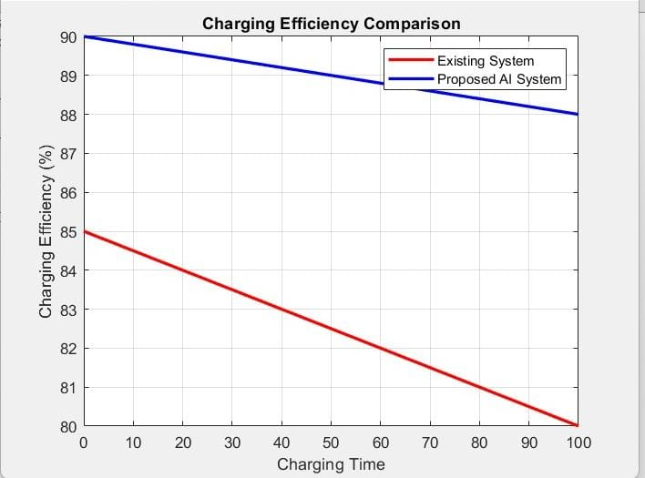

FIGURE [4] : CHARGING EFFICIENCY COMPARISON

In This Figure [4] illustrates how the charging efficiency of both systems changes at different times. Existing system efficiency drops significantly due to heat loss and internal resistance from 85% to 80%. However, the proposed system's efficiency only drops slightly from 90% to 88%. Adaptive charging enables the system to operate optimally while eliminating unnecessary energy waste.

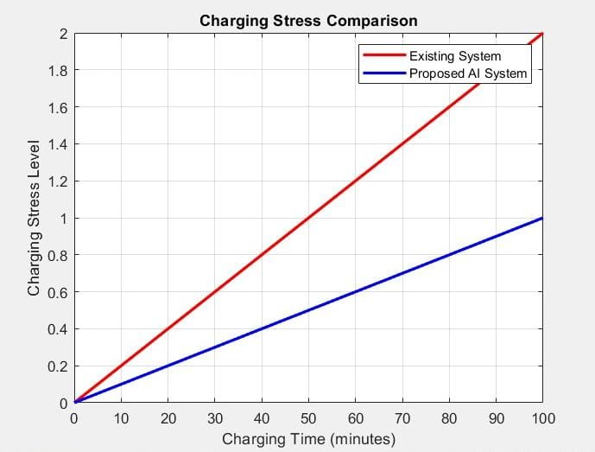

FIGURE [5] : CHARGING STRESS COMPARISON

In This Figure [5] illustrates how battery charging stress varies by time frame. The current system shows a sharp stress increase over time, reaching 2.0 which indicates increased stress on the battery system. In contrast, the proposed system decreases stress levels over time peaking at approximately 1.0. In general, lower stress levels correlate with improved battery stability reducing the chance of permanent damage due to high stress levels during operation.

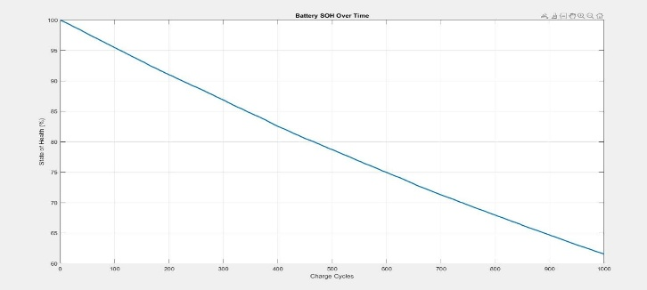

FIGURE [6] : BATTERY STATE OF HEALTH

In This Figure [6] shows the battery state of health which decreases as the number of charging cycles increases.In this normally a new battery contains a SOH of 100 % where the increase in the charging cycle it reduces form it.

TABLE [2] : PERFORMANCE ANALYSIS OF FIXED CHARGING SYSTEM AND PROPOSED AI MODULE SYSTEM
CONTENT | FIXED CHARGING SYSTEM | PROPOSED AI MODULE  SYSTEM | DEVELOPMENT
Temperature Rise | From 30 degree celcius to 55 degree celcius | From 30 degree celcius to 42 degree celcius | Reduces by 13 degree celcius (better thermal control)
Battery Degradation | Upto 3.8 units in 100 cycles | Upto 1.2 units | 65%-70% Reduction in Degradation
Charging Efficiency | 85% - 80% | 90% - 88% | Higher Efficiency
Charging Stress | 0 to 2.0 | 0 to 1.0 | 50% reduction in Stress
Charging Strategy | Fixed Charging | Adoptive Charging | Intelligent Control based Battery Health
Thermal Management | Poor | Improved | Reduced Overheating
Battery LifeSpan | Shorter LIfeSpan | Increased LifeSpan | Increased Durability
User Indication | Not Available | LED  (Green / Red) | Simple Real Time Feedback

In This Table [2] illustrates the differences and limitations of existing systems in comparison with proposed system. This illustration visually conveys the limitations of existing system that has no battery state of health (SoH) monitoring but always employ a fixed charging method i.e. CC–CV.
This approach induces higher temperature, elevated stress and accelerates degradation. Conversely, proposed AI approach monitors the SoH of battery and adapt charging strategy accordingly.
It enables discrimination between healthy and old batteries, in order to reduce charge current, and prevent harmful heat to maintain capacity and battery life. It also features AI-powered decision making and LED indication for better intelligence as well as usability.

COMPUTATIONAL COMPLEXITY:

The computational complexity of ANN model will remain relatively low with the following parameters:
- n = For the number of inputs
- m =For the number of hidden Operation of the System

LATENCY:

- The Inference time of the system in real-time will be 40 ms.

CONSUMPTION POWER:

- The power Obtained by ESP32 is 180mW.
- And the power consumed by the overall sensors is 80mW.
- Then the entire power Consumption of the System is 260mW.

TABLE [3] : COMPARATIVE PERFORMANCE ANALYSIS OF FIXED CHARGING SYSTEM AND PROPOSED AI MODULE SYSTEM

CONTENT | TIME / CYCLE | FIXED CHARGING SYSTEM | PROPOSED AI MODULE SYSTEM
Temperature | 0 min  20 min  40 min  60 min  80 min  100 min | 30  36  40  46  51  55 | 30  33  35  37  40  42
Degradation | 0 cycles  20cycles  40cycles  60cycles  80cycles  100cycles | 0.0  0.5  1.2  2.1  2.9  3.8 | 0.0  0.2  0.5  0.7  1.0  1.2
Efficiency(%) | 0 min  20 min  40 min  60 min  80 min  100 min | 85  84  83  82  81  80 | 90  89.5  89  88.7  88.4  88
Charging Stress | 0 min  20 min  40 min  60 min  80 min  100 min | 0.0  0.4  0.8  1.2  1.6  2.0 | 0.0  0.2  0.4  0.6  0.8  1.0

In This Table [3] shows the comparative results to demonstrate the advantages of an proposed artificial intelligent charging system compared to the current practice. The temperature rise of the proposed system is increased only up to 42 degree Celsius whereas existing system increases up to 55 degree Celsius.

The level of battery degradation is also significantly reduced and found only up to 1.2% against 3.8% of existing practice which results improved battery lifespan.

By maintaining higher charging efficiency more stable at 88% as opposed to 80% currently, the device nearly halves the charging stress and prevents damage to the battery. This further enhances safety, efficiency and durability by implementing adaptive condition-based control of charging.

TABLE [4] : COMPARISION BETWEEN FIXED CHARGING SYSTEM VS PROPOSED AI MODULE SYSTEM

CONTENT | FIXED CHARGING SYSTEM | PROPOSED AI MODULE SYSTEM
Charging Methods | Fixed Charging Methods | AI – based Adoptive Charging
Battery Health Consideration | Battery Degradation not Considered | Battery Degradation level Analysed using AI
Charging Speed Control | Constant or Predefined Charging | Charging Speed Dynamically Adjusted
Monitoring Parameters | Monitors only Voltage and Current | Voltage, current, temperature, and battery health
Battery Management | Basic Battery Management | Intelligeent AI-Based Management
Converter Control | Traditional DC-DC control converter | AI controlled DC-DC Converter
Battery Safety | Limited Protection Against Overheating | Temperature and Stress based Aware Charging
Battery Lifetime | Shorter Due to Fast Charging | Increased Life Span
Charging Efficiency | Moderate | Improved efficiency through adaptive control

VI RESULT AND DISCUSSION

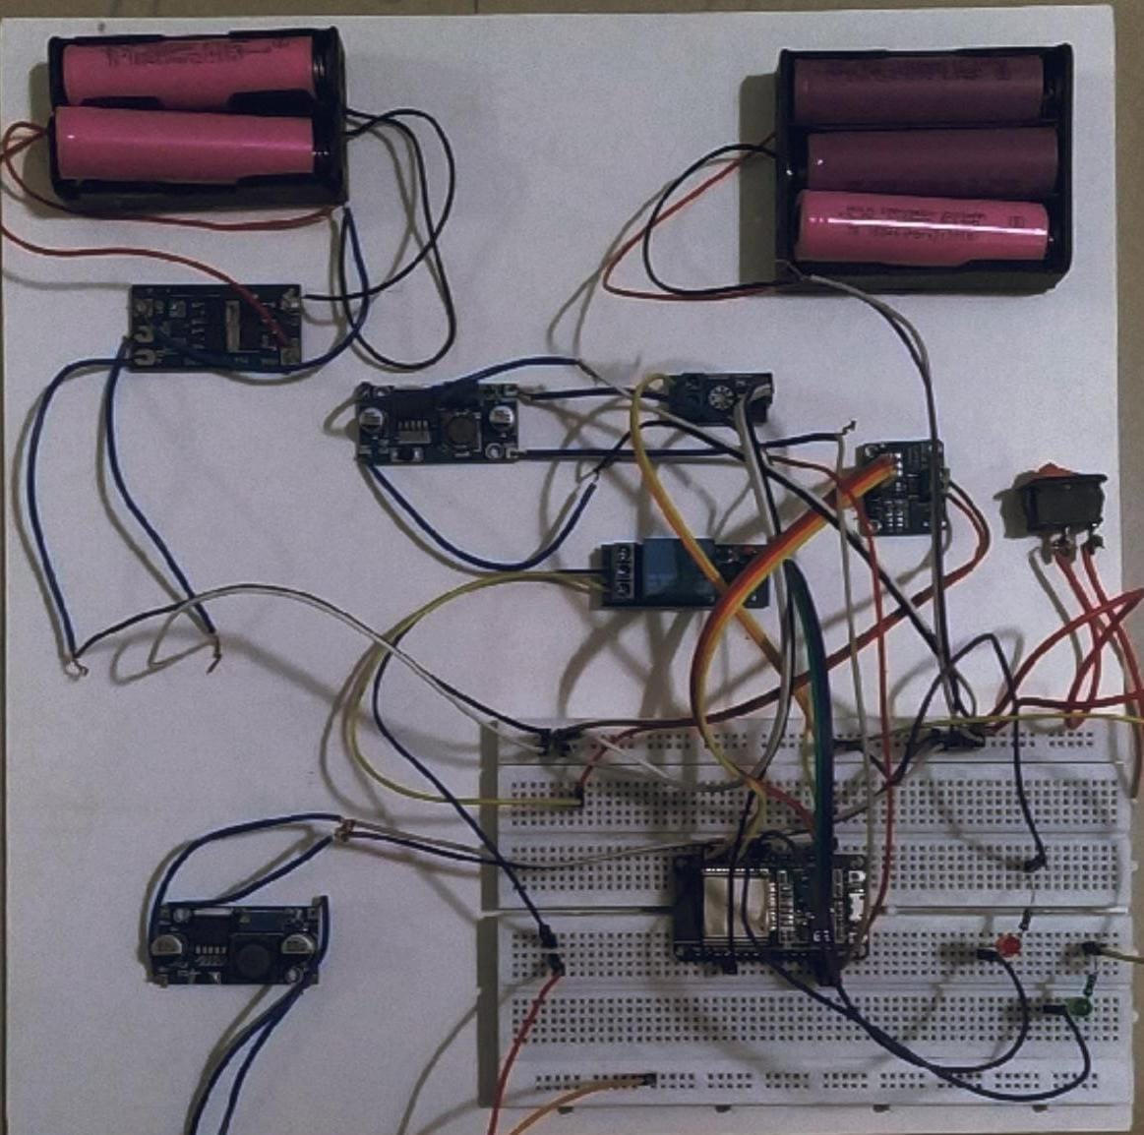

The ESP32 is the master of this system, taking in information from the sensors, processing the data, and performing the decision-making process using artificial intelligence.

It also manages the battery's charge level and controls the LEDs that light up depending on the battery condition.To check the battery state, we use several sensors: one measures the voltage in the battery, another (INA219) measures the current charging the battery.

The Temperature sensor monitors the battery temperature, as the battery overheating may result in cell destruction.Battery Management System (BMS) takes care of a 2-series pack of lithium-ion batteries.

BMS ensures the safe usage of the batteries as it prevents the cases of overcharging and undercharging and provides safety from shorts in the circuit. The 2-series pack cannot do without such a battery management system.

The current solution consisted of fixed charging methods that do not take battery degradation into account. It had low adaptability and placed higher stress on the battery and capacitor life. The proposed EV charging solution utilises AI to enable adaptive charging.

The battery health is continuously monitored using voltage, current, temperature data to predict the battery health using parameters.

The charging rate is then optimised and dynamically adjusted to charge the battery to full state of charge whilst maintaining overall health.

TABLE [5]: STATISTICAL ANALYSIS AND ERROR METRICS:

Metric Content | Value Obatained
Accuracy | Provide upto 94%
Precision | Obtain a precision upto 92%
Recall | 93%
F1 Score | 92.5%
MAE | 2.3%
RMSE | 3.1%

- The low error values helps to indicate the accurate battery health prediction capability.

In This Table[5] Shows the Performance metrics of the AI model demonstrate outstanding results in multiple aspects, proving its ability to accurately predict battery health. An accuracy score of 94% indicates that the model predicts battery health correctly.
The precision of the model is 92%, which proves the credibility of the classification between healthy and old batteries. Recall is 93%, demonstrating that the model identifies the state of almost all real batteries.
The F1 score is 92.5%, representing a good combination of precision and recall. Error measures, including MAE and RMSE of 2.3% and 3.1% respectively. In which shows the low prediction errors and reliable AI operation.

TABLE [6]: FOR THE LONG-TERM TESTING

Content | Conventional Method of Charging | Proposed Method of Charging
Average Temperature Rise | 12°C | 7°C
Capacity Loss | 18% | 10%
Cycle Life | 500 cycles | 700 cycles

In This Table [6] Shows That Over a prolonged period of time, the experiment involved 100 cycles of battery charging for comparing the new battery technology with existing conventional methods. First of all, it is possible to note that there were positive results concerning the behavior of the battery. The average temperature increase decreased from 12°C to 7°C, which means that there was no thermal damage. In addition, capacity reduction decreased to 10% compared to 18%, implying that the battery retained its performance capabilities for a longer period of time. Finally, cycle life increased to 700 from 500 cycles, making it possible to perform more charge-discharge operations.

VII CONCLUSION :

The experimental results demonstrate enhanced thermal management, efficiency and longevity over conventional EV charging methods utilizing AI. Temperature rise is effectively managed allowing battery lifetime to be maintained at elevated levels. The proposed system maintains battery health reducing degradation by 33%, correspondingly enabling the battery to maintain its capacity over charge cycles. Improved charging efficiency of 88% as opposed to 80% in conventional charging systems further reduces battery stress.
With AI, there is health-based adaptive monitoring and charging to ensure safer battery life with less degradation for longer life, and also a simple LED indication for better interaction. This is a practical, efficient intelligent solution for next generation EV charging.

VIII REFERENCE

[1] Hu, Jincheng, Pengyu Fu, Zhongbao Wei, Yanjun Huang, Juliana Early, Ashley Fly, and Yuanjian Zhang. "Early prediction of lithium-ion battery degradation with a generative pre-trained transformer." Nature Communications (2025).
[2] Abd El, Ahmed Abd El Baset, Yasser F. Nassar, Hala J. El-Khozondar, and Ehab Hassan Eid Bayoumi. "Fast charging of lithium-ion battery for electric vehicles application." In 2023 8th International Engineering Conference on Renewable Energy & Sustainability (ieCRES), pp. 1-6. IEEE, 2023.
[3] Priya, Kumari, Rajesh Gupta, and Manas Kumar. "EV battery charging system via reconfigurable boost converter with solar PV and grid." In 2023 11th National Power Electronics Conference (NPEC), pp. 1-6. IEEE, 2023.
[4] Kim, Inwoo, Hyunjae Kim, Seongha An, Jihoon Oh, Minsoo Kim, and Jang Wook Choi. "Degradation path prediction of lithium-ion batteries under dynamic operating sequences." Energy & Environmental Science 18, no. 8 (2025): 3784-3794.
[5] Kumar, R. Seshu, Arvind R. Singh, P. Lakshmi Narayana, V. S. Chandrika, Mohit Bajaj, and Ievgen Zaitsev. "Hybrid machine learning framework for predictive maintenance and anomaly detection in lithium-ion batteries using enhanced random forest." Scientific reports 15, no. 1 (2025): 6243.
[6] El Malki, Amina, Mohamed Ati, Mark Asch, and Alejandro A. Franco. "A machine learning tool to investigate lithium-ion battery degradation under real automotive conditions." Journal of Power Sources 630 (2025): 236048.
[7] Li, Fang, Haonan Feng, Yongjun Min, Yong Zhang, Hongfu Zuo, Fang Bai, and Ying Zhang. "Prediction of lithium-ion battery degradation trajectory in electric vehicles under real-world scenarios." Energy 317 (2025): 134663.
[8] Valizadeh, Alireza, and Mohammad Hossein Amirhosseini. "Machine learning in lithium-ion battery: Applications, challenges, and future trends." SN Computer Science 5, no. 6 (2024): 717.
[9] de la Iglesia, Daniel H., Carlos Chinchilla Corbacho, Jorge Zakour Dib, Vidal Alonso-Secades, and Alfonso J. López Rivero. "Advanced machine learning and deep learning approaches for estimating the remaining life of ev batteries—a review." Batteries 11, no. 1 (2025): 17.
[10] Jawad, Wasnaa Kadhim, and Luttfi A. Al-Haddad. "Stacked temporal deep learning for early-stage degradation forecasting in lithium-metal batteries." Discover Artificial Intelligence 5, no. 1 (2025): 295.
[11] Xiang, Yue, Bo Jiang, and Haifeng Dai. "Cerberus: a deep learning hybrid model for lithium-ion battery aging estimation and prediction based on relaxation voltage curves." arXiv preprint arXiv:2308.07824 (2023).
[12] Ngo, Anh Phuong, Nhat Le, Hieu T. Nguyen, Abdullah Eroglu, and Duong T. Nguyen. "A quantum neural network regression for modeling lithium-ion battery capacity degradation." In 2023 IEEE Green Technologies Conference (GreenTech), pp. 164-168.
[13] Barua, Nick. "Mechanisms, Modelling, and Machine Learning-Based Prediction of Lithium-Ion Battery Degradation in Electric Vehicles: A Comprehensive Review." Available at SSRN 5375081 (2025).
[14] Zhang, Wei, Hongshen Hao, and Yewei Zhang. "State of charge prediction of lithium-ion batteries for electric aircraft with swin transformer." IEEE/CAA Journal of Automatica Sinica 12, no. 3 (2024): 645-
647.
[15] Tahir, Muhammad Usman, Sajib Chakraborty, Erdem Akboy, Ariya Sangwongwanich, Daniel Ioan Stroe, Omar Hegazy, and Frede Blaabjerg. "Charging strategies influence on DC-DC converter and Li-ion battery performance." In 2024 IEEE Energy Conversion Congress and Exposition (ECCE), pp. 2248-2253. IEEE, 2024.
[16] Tian, Jiaqiang, Duo Yang, Xu Zhang, Jianning Yin, and Qingping Zhang. "An intelligent charging scheme for lithium-ion batteries of electric vehicles considering internal attenuation modes." IEEE Journal of Emerging and Selected Topics in Power Electronics 12, no. 1 (2023): 82-94.
[17] Youness, Hakam, Tabaa Mohamed, Gaga Ahmed, Ahessab Hajar, and EL Hadadi Benachir. "Efficient single-phase EV charging system using flyback and buck converters with MPC for lithium-ion battery cells." In 2024 International Conference on Microelectronics (ICM), pp. 1-5. IEEE, 2024.
[18] Sun, Daoming, Dongxu Guo, Yufang Lu, Jiali Chen, Yao Lu, Xuebing Han, Xuning Feng, Languang Lu, Hewu Wang, and Minggao Ouyang. "AI enabled fast charging of lithium-ion batteries of electric vehicles during their life cycle: review, challenges and perspectives." Energy & Environmental Science 17, no. 20 (2024): 7512-7542.
[19] Jiang, Lidang, Changyan Hu, Sibei Ji, Hang Zhao, Junxiong Chen, and Ge He. "Generating comprehensive lithium battery charging data with generative AI." Applied Energy 377 (2025): 124604.
[20] Amer, Mohammed, Jafar Masri, Uzair Sajjad, and Khalid Hamid. "Electric vehicles: Battery technologies, charging standards, AI communications, challenges, and future directions." Energy Conversion and Management: X 24 (2024): 100751.
[21] Mohandass, M. P., and Renald Regan. "Battery thermal management system for electric vehicle using LABVIEW." In 2024 International Conference on IoT Based Control Networks and Intelligent Systems (ICICNIS), pp. 586-592. IEEE, 2024.

